Dynatrace AppMon Testing Scenarios for



Publication Detail

Prepared by:
PT Mitra Integrasi Informatika
APL Tower, Lt. 37ᵗʰ Suite 1- 8
Jl. Letjen S. Parman Kav. 28
Jakarta 11470

Date: July 27, 2018 Version: 1.0

Document version
Version | Date | Author | Remarks
1.0 | August 1, 2018 | Miftah Reza Maulana | Intial Document

Document authorization
PT. Mitra Integrasi Informatika |  | PT. Manulife Indonesia |  | PT. Manulife Indonesia
Rahmat Julizar |  | Wayan Budiastika |  | Adi Wijaya Sutanto
Date: |  | Date: |  | Date:

Table of Contents
Publication Detail 0
Document version 1
Document authorization 1
1. Introduction 4
2. Reference 4
3. Abbreviation List 4
4. Architecture of Dynatrace Implementation 5
5. Installation & Configuration 7
5.1 Server Installation 7
5.2 Collector Installation 11
5.3 Client Installation 15
5.4 Agent Installation 17
5.4.1 IIS (Web Server) Agent 17
5.4.2 NET (Application) Agent 27
5.5 Server Configuration 36
5.5.1 License Setup Configuration 36
5.5.2 Server Setup Configuration 40
5.5.3 Service Setup Configuration 41
5.5.4 Collector Setup Configuration 43
5.5.5 Performance Warehouse Setup Configuration 44
5.5.6 Users Setup Configuration 45
5.5.7 Plugin Setup Configuration 47
5.5.8 Update Setup Configuration 48
5.5.9 Storage Setup Configuration 53
5.5.10 Infrastructure Setup Configuration 54
5.5.11 Database Setup Configuration 55
5.5.12 Synthetic Monitoring Setup Configuration 56
5.6 System Profile Configuration 57
5.6.1 Sensor Setup Configuration 57
5.6.2 Measures Setup Configuration 59
5.6.3 Business Measures Setup Configuration 60
5.6.4 Schedule Setup Configuration 61
5.6.5 Task Setup Configuration 62
5.6.6 Monitors Setup Configuration 63
5.6.7 Incidents Setup Configuration 64
5.6.8 Error Detection Setup Configuration 65
5.6.9 Application Setup Configuration 66
5.6.10 User Experience Setup Configuration 67
6. Attachment (Optional) 68

Introduction
The purpose of this document is as the reference in the application testing process with some pre-defined scenarios to ensure that the application (Dynatrace AppMon) are installed and configured properly in the production environment of Manulife.

Testing Scenario
The table below are the scenario that will be used in application testing process.
Testing Scenario
No. | Scenario | Detail
1. | Service Monitoring | - Testing on Service Monitoring for the entire application
 |  | - Testing on Setup Threshold
 |  | - Testing on Dashboard Performance for the entire application including Infrastructure
2. | Anomaly Detection & Alert | - Testing on Anomaly Process detection
 |  | - Testing on Alert Notification as trigger of detection
3. | Application Debugging | - Testing on Root Cause determination based on anomaly/issue that occured
 |  | - Testing on Source Code lookup based on anomaly/issue that occured
4. | Impacted System | - Testing on showing Impacted System based on issue that occured
5. | Report & Dashboard | - Testing on changing Report or Dashboard view
 |  | - Testing on export a Report to Excel, PDF or PowerPoint
 |  | - Testing on real-time Dashboard Monitoring
 |  | - Testing on breakdown Report or Dashboard
6. | Archiving | - Testing on Archiving capability

2.1. Service Monitoring
The list of testing below use for Service Monitoring testing process.

Testing on Service Monitoring for the entire application
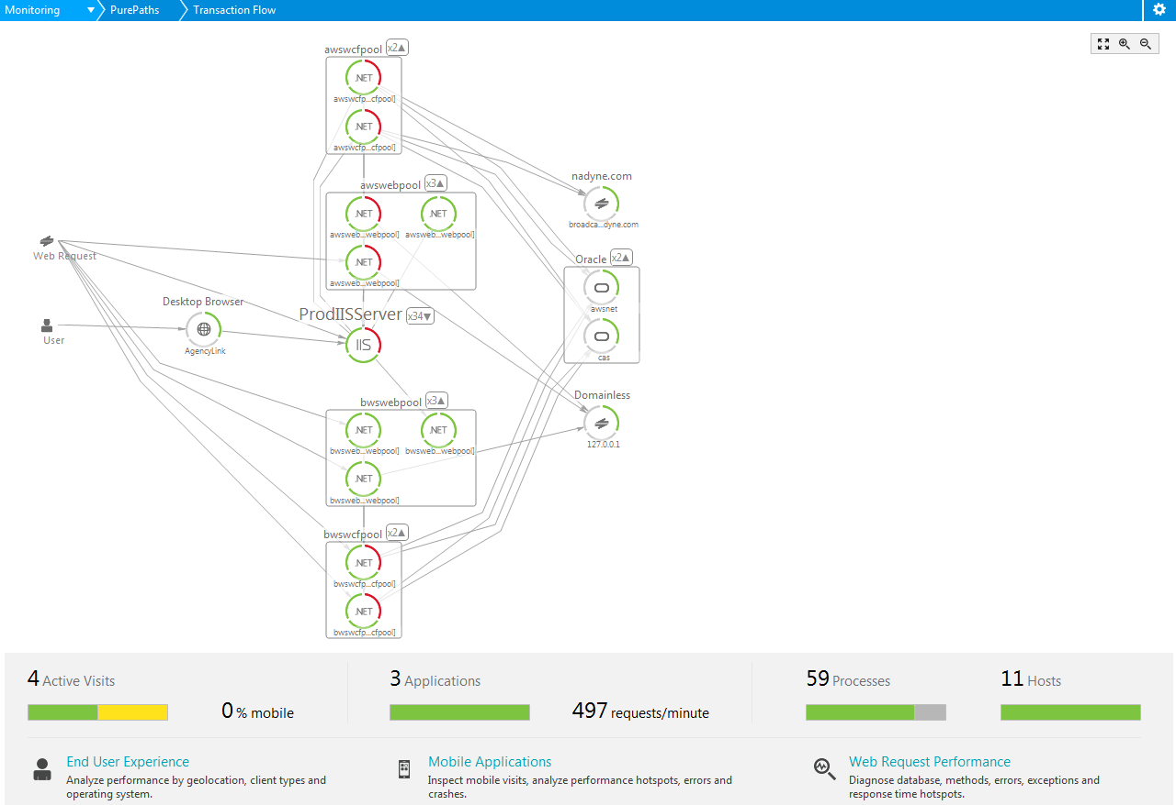
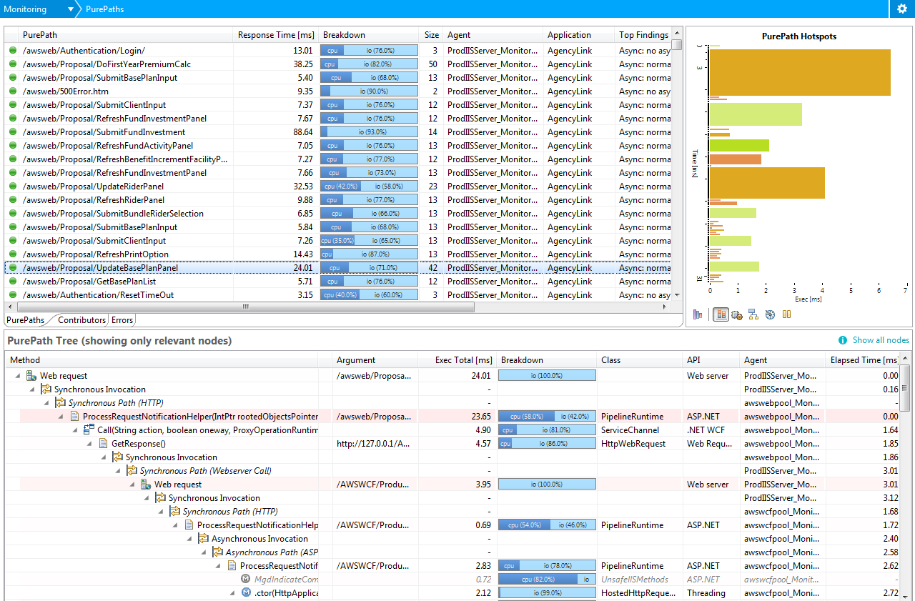

Testing on Setup Threshold
Aasd
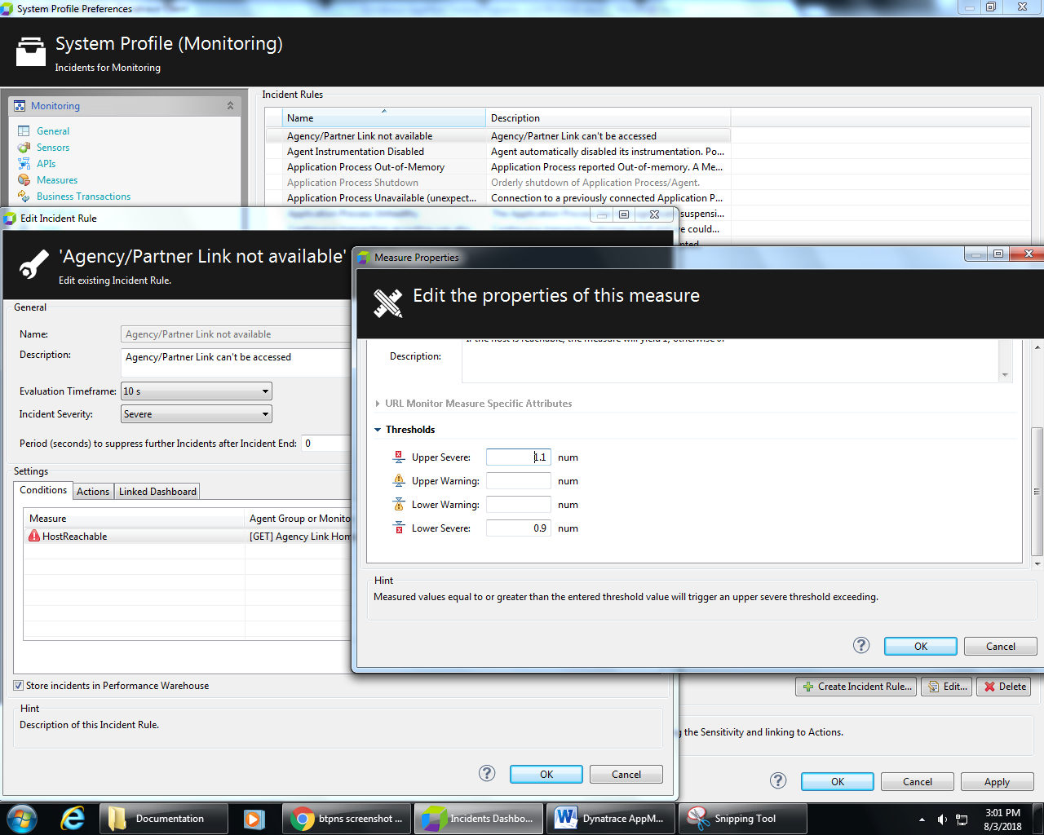

Testing on Dashboard Performance for the entire application
Asdasdas
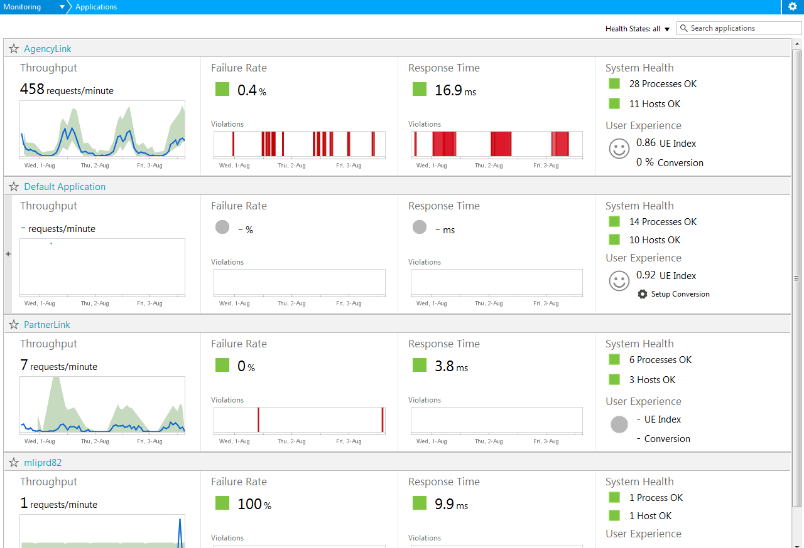
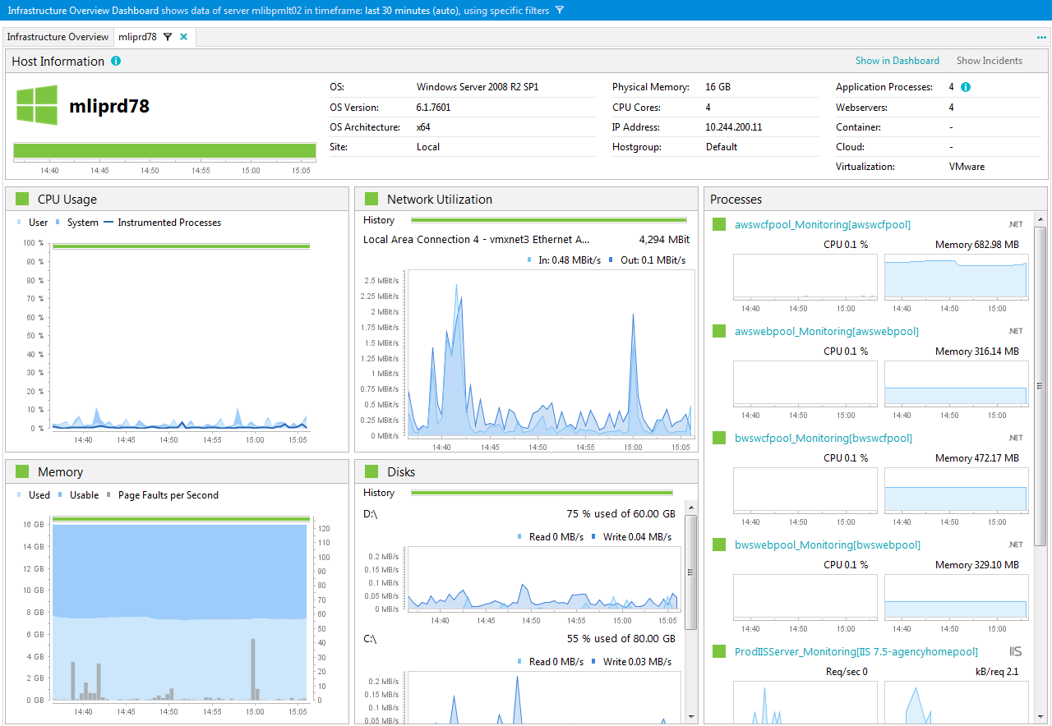

2.2 Anomaly Detection & Alert
The table below are the scenario that will be used in application testing process.

2.2.1 Testing on Anomaly Process detection
Asdasd
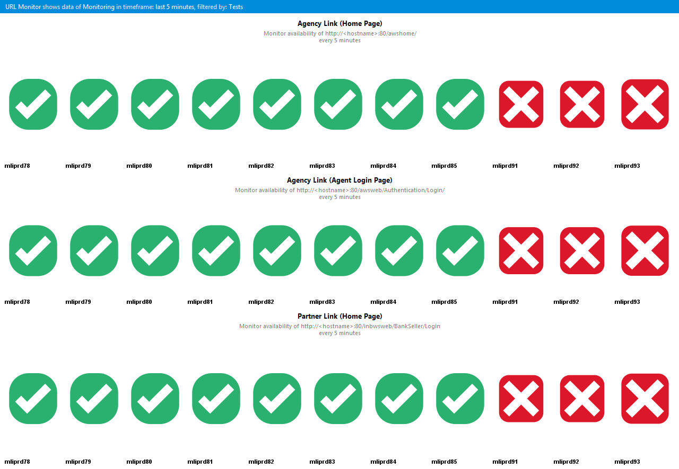

2.2.2 Testing on Alert Notification as trigger of detection
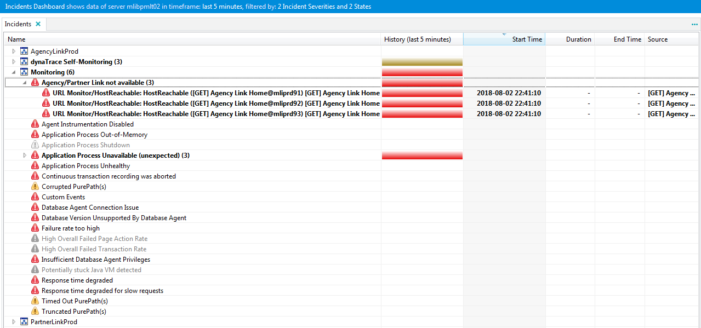

2.3 Application Debugging
The table below are the scenario that will be used in application testing process.

Testing on Root Cause determination based on anomaly/issue that occurred
Asdasd

Testing on Source Code lookup based on anomaly/issue that occured
asas

2.4 Impacted System
The table below are the scenario that will be used in application testing process.

Testing on showing Impacted System based on issue that occured
asdasd
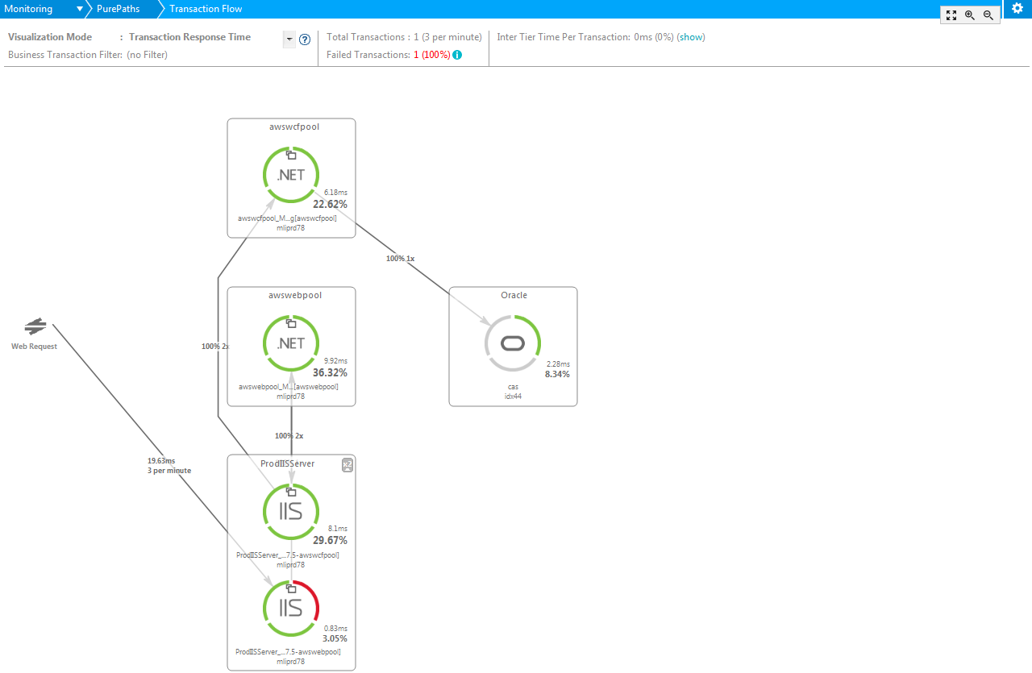

2.5 Report & Dashboard
The table below are the scenario that will be used in application testing process.

Testing on changing Report or Dashboard view
Asdasd

Testing on export a Report to Excel, PDF or PowerPoint
Asdas

Testing on real-time Dashboard Monitoring
Asdasd

Testing on breakdown Report or Dashboard
Asdasd

2.6 Archiving
The table below are the scenario that will be used in application testing process.

Testing on Archiving capability

Attachment (Optional)

